Visors – Assembly

Prepare the parts
  - Pop out cut-outs in parts Slots and cut outs, including the little circles on the strap part.
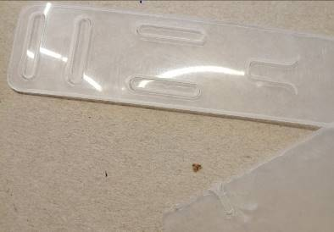
  - Check edges for burrs and clean with craft knife/ruler edge/other…

Assemble the headband
There are three parts to the headband
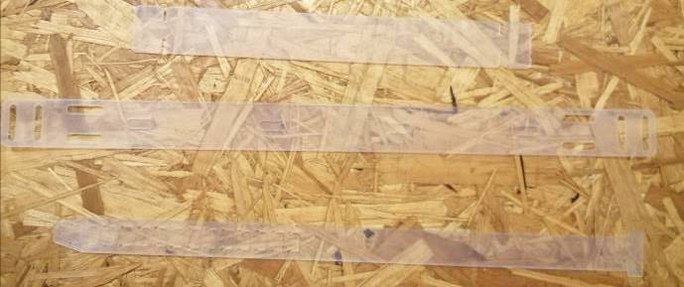
Part 1 – Headband Spacer
Part 2 – Headband Front
Part 3 – Headband Strap

  - Inset the headband spacer (Part 1) into the front headband part (Part 2) – push the tabs fully down to allow the other tab to fit into the cut out slot.
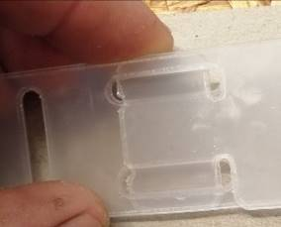
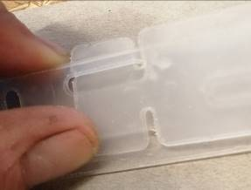
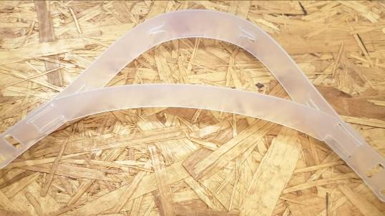
  - Insert the strap into the assembled headband front. Inset the strap so that the Tab is on the outside of the headband.
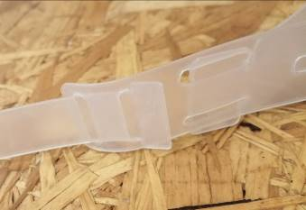
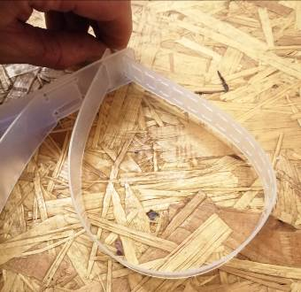

  - Inset the other end of the strap into the other side of the headband, again making sure the tab is on the outside of the band.
Set one of the tabs in position (as an example for the user)
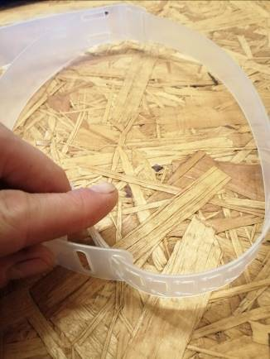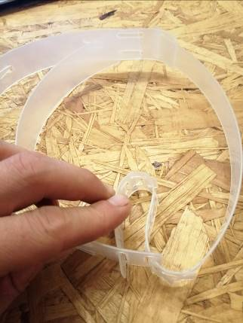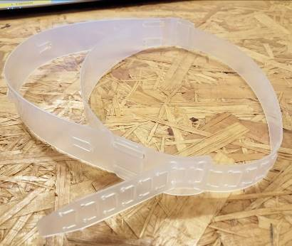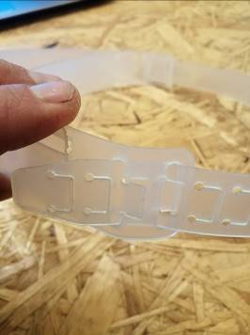

Put the Acetate visor sheet onto the front of the headband.

